UNIT I

Operating System - Introduction, Structures - Simple Batch,
Multiprogrammed, Time-shared, Personal Computer, Parallel, Distributed Systems, Real-Time Systems, System components, Operating System services, System Calls.

Operating System – Introduction

- Computer System = Hardware + Software
- Software = Application Software + System Software(OS)
- System Software: System software is a set of computer programs that is designed to manage system resource (central processing unit (CPU), computer memory, file storage, input/output (I/O) devices, and network connections.). It is also helps application programs to execute correctly.
- Examples : Operating System, Programming Language Translators, Device Drivers.

Application Software : Application software is a computer program designed to help people perform an activity. Depending on the activity for which it was designed, an application can manipulate text, numbers, audio, graphics, and a combination of these elements.
- It acts as a mediator between the end-user and system software.
- Examples: Education softwares, Entertainment softwares, Data base Softwares…etc.

Operating System Definition:

• An Operating System is a system Software that acts as an intermediary/interface between a user of a computer and the computer hardware.
Examples: Windows OS, Linux OS, MS-DOS ,Android OS, Mac OS..etc.
Operating system goals or Objectives:
- Ability to evolve: Execute user programs and make solving user problems easier
- Convenience: Make the computer system convenient to use
- Efficiency: Use the computer hardware in an efficient manner
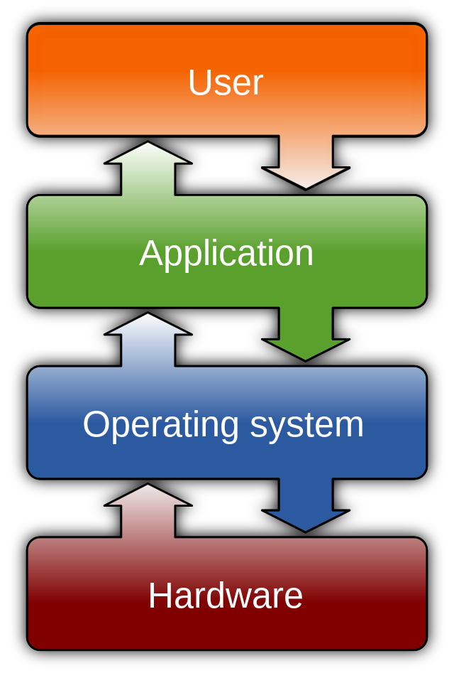
Advantage of Operating System:
- Offers an environment in which a user may execute programs/applications
- The operating system must make sure that the computer system convenient to use
- Operating System acts as an intermediary among applications and the hardware components
- It provides the computer system resources with easy to use format.
Disadvantages of Operating System
- If any issue occurs in OS, you may lose all the contents which have been stored in your system
- It is never entirely secure as a threat can occur at any time.

conceptual view of a computer system:
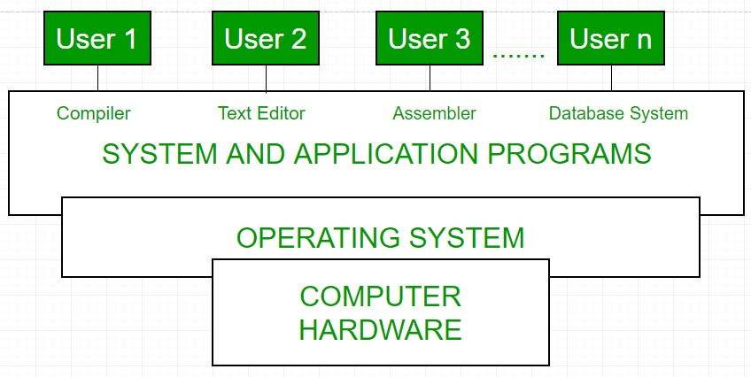
- An OS is an important part of every computer system.
- A computer system can be divided roughly in to 4 components. The hardware, OS,The application programs and the user.
- The hardware consists of memory, CPU, ALU, I/O devices, Storage devices,Peripheral devices.
- System software consists of compilers, loaders,editors,OS etc.
- Application software consists of business programs, data base programs.
Operating system performs the following functions:
- Booting : Booting is a process of starting the computer operating system starts the computer to work. It checks the computer and makes it ready to work.
- Memory Management :It is also an important function of operating system. The memory cannot be managed without operating system. Different programs and data execute in memory at one time. if there is no operating system, the programs may mix with each other. The system will not work properly.
- Loading and Execution: A program is loaded in the memory before it can be executed. Operating system provides the facility to load programs in memory easily and then execute it.
- Data security Data is an important part of computer system. The operating system protects the data stored on the computer from illegal use, modification or deletion.
- Disk Management : Operating system manages the disk space. It manages the stored files and folders in a proper way.
- Process Management : CPU can perform one task at one time. if there are many tasks, operating system decides which task should get the CPU.
- Device Controlling: operating system also controls all devices attached to computer. The hardware devices are controlled with the help of small software called device drivers.

Operating System Mode:
  - The User Mode is concerned with the actual interface between the user and the system.
  - It controls things like running applications and accessing files.
  - The Kernel Mode is concerned with everything running in the background.
  - It controls things like accessing system resources, controlling hardware functions and processing program instructions. Kernel:
  - A Kernel is the central component of an Operating System.
  - The Kernel is also said to be the heart of the Operating System. It is responsible for managing all the processes, memory, files, etc.

OS Structures or Approaches

- OS can be implemented with the help of various structures. The structure of the OS depends mainly on how the various common components of the OS are interconnected and melded into the kernel.
- Depending on this we have following structures of the operating system:
  - Simple Structure
  - Layered Structure
  - Micro-Kernel
  - Modular Structure

1. Simple Structure:
- There are many operating systems that have a rather simple structure.
- First started as small systems and rapidly expanded much further than their scope.
Example: MS-DOS
- MS_DOS interfaces and levels of functionality are not well separated.
- In MS-DOS application programs are able to access the basic I/O routines.
- These type of OS cause the entire system to crash if one of the user programs fails.
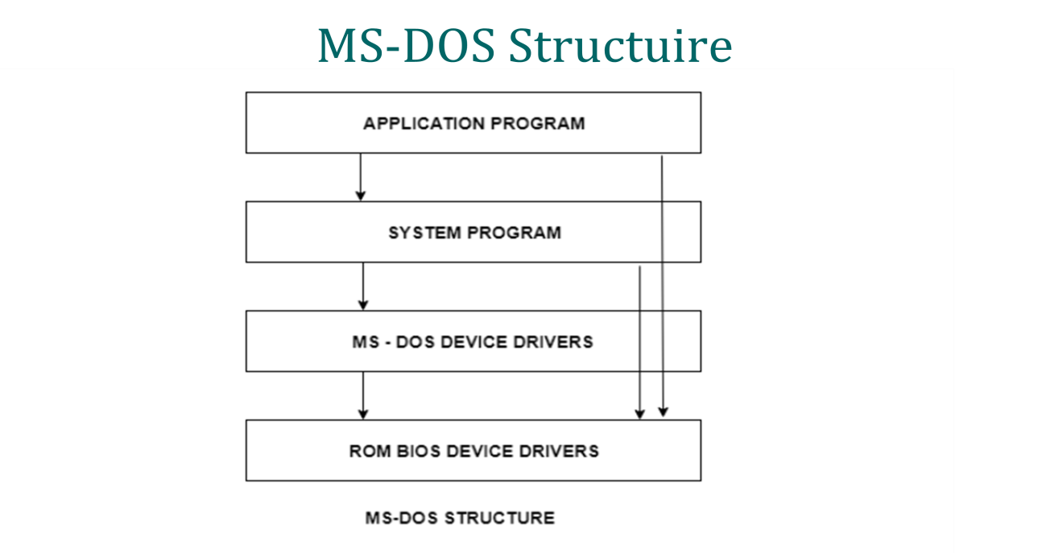

Advantages of Simple structure:
- It delivers better application performance because of the few interfaces between the application program and the hardware.
- Easy for kernel developers to develop such an operating system.
Disadvantages of Simple structure:
- The structure is very complicated as no clear boundaries exists between modules.
- It does not enforce data hiding in the operating system.

2. Layered Structure:

- Layered Structure is a type of system structure in which the different services of the operating system are split into various layers(levels), where each layer has a specific well-defined task to perform.
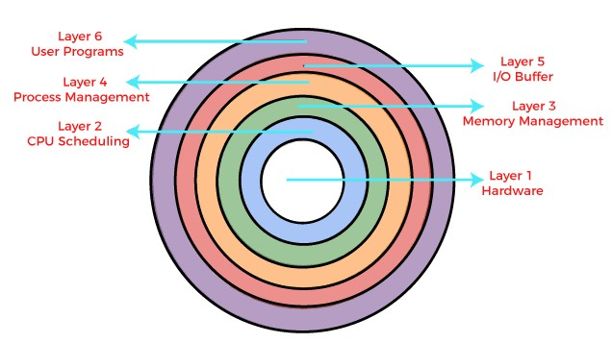

- The bottom layer (layer 0) is the hardware, and the topmost layer (layer N) is the user interface.
- These layers are so designed that each layer uses the functions of the lower-level layers only. It simplifies the debugging process as if lowerlevel layers are debugged, and an error occurs during debugging. The error must be on that layer only as the lower-level layers have already been debugged.

Details about the six layers are:

- Hardware: This layer interacts with the system hardware and coordinates with all the peripheral devices.
- CPU Scheduling: This layer deals with scheduling the processes for the CPU. There are many scheduling queues that are used to handle processes.
- Memory Management: Memory management deals with memory and the moving of processes from disk to primary memory for execution and back again.
- Process Management: This layer is responsible for managing the processes i.e assigning the processor to a process at a time. This is known as process scheduling.
- I/O Buffer or Device Management: I/O devices are very important in the computer systems.This layer handles the buffers for the I/O devices and makes sure that they work correctly.
- User Programs:This layer deals with the many user programs and applications that run in an operating system such as word processors, games, browsers etc.

Advantages of Layered Structure:

- 1.Easy update: A modification made in a particular layer will not affect the other layers.
- 2.No direct access to hardware: The hardware layer is the innermost layer present in the design. So a user can use the services of hardware but cannot directly modify or access it.
- 3.Easy debugging: Suppose an error occurs in the CPU scheduling layer. The developer can only search that particular layer to debug.

Disadvantages of Layered Structure:

1.Communication: No communication between non-adjacent layers.
2.Slower in execution: If a layer wants to interact with another layer, it requests to travel through all the layers present between the two interacting layers. Thus it increases response time.

3. Micro-Kernel

Kernel:
- It is the central component of an OS that handles system resources. It also acts as a bridge between the computer's application and hardware.
- It is in charge of various activities, including task management, disk management, and memory management.
Microkernel:
- This structure designs the OS by removing all non-essential( functions, data) components from the kernel and executing them in user mode.This result in a smaller kernel called the “ Micro-Kernel”.
Example: Mac OS

Advantages of Microkernel:

- Microkernels are modular and the different modules can be replaced, reloaded, modified, changed etc. as required. This can be done without even touching the kernel.
- Microkernels are small so these can be tested effectively.

Disadvantage of Microkernel:

- To write a microkernel more code is required.
- If a service crashes, it does effects on working on the microkernel.

4. Modular Structure or Modular Kernel

- It is considered as the best approach for an OS.
- It is a type of kernel in which some parts of system core will get allocated in independent files called modules. This can be added to system at run time. It usually requires small amount of time of load modules. If one needs a new module, then they won't have to recompile.
Example: Solaris OS
- Modular OS design uses OOPS techniques to create a modular kernel.
Advantages

- Efficient
- Easy to maintained
- Easy to debug and update
➢
Disadvantages

- It may lose stability
- Less security

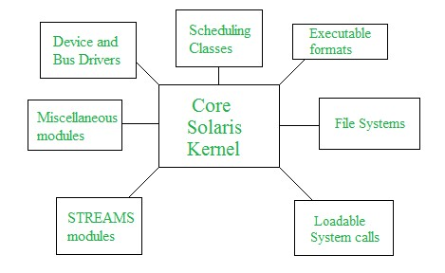

Types of Operating Systems

➢ Following are some of the most widely used types of OS (Operating System):
- Simple Batch Operating System
- Multiprogramming Operating System
- Multitasking/Time Sharing Operating System
- Distributed Operating System
- Real Time Operating System
- Personal Computer Operating System
- Parallel or tightly coupled or Multiprocessing Operating System.

1. Simple Batch Operating System

- The users of a batch operating system do not interact with the computer directly.
- There is an operator which takes similar jobs having the same requirement and group them into batches.
- Batch means set of jobs/processes with similar needs.

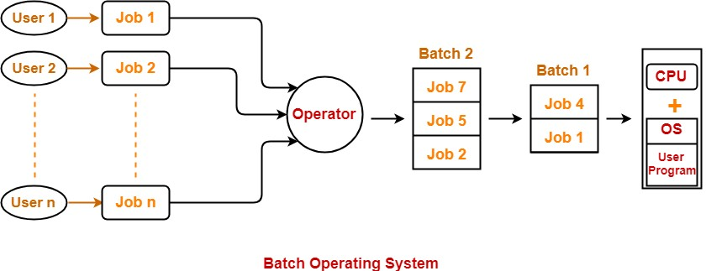
- Firstly, user prepares his job using punch cards.
- Then, he submits the job to the computer operator.
- Operator collects the jobs from different users and sort the jobs into batches with similar needs.
- Then, operator submits the batches to the processor one by one.
- All the jobs of one batch are executed together. Example: Bank Statements

Advantages of Batch Operating System:

- Multiple users can share the batch systems.
- The idle time for the batch system is very less.
- It is easy to manage large work repeatedly in batch systems.
➢
Disadvantages of Batch Operating System:

- Batch systems are hard to debug.
- It is sometimes costly.
- The other jobs will have to wait for an unknown time if any job fails.

2. Multiprogramming Operating System

- This type of OS is used to execute more than one jobs simultaneously by a single processor(CPU).
- A program in execution is called a "Process", "Job" or a "Task".
- Each process needs two types of system time: CPU time and IO time.
- Example: User can use MS-Excel , download apps, transfer data from one point to another point, Firefox or Google Chrome browser, and more at a same time.
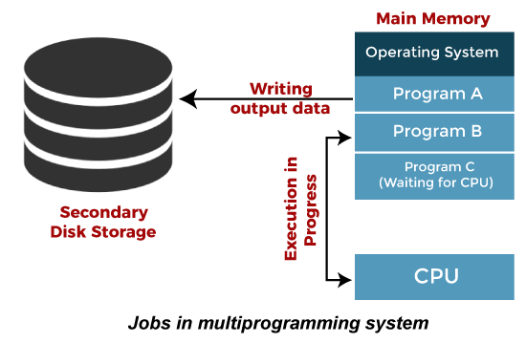

- Multiprogramming operating systems use the mechanism of job scheduling and CPU scheduling.

Advantages of Multiprogramming OS
- Throughout the system, it increased as the CPU always had one program to execute.
- Response time can also be reduced.

Disadvantages of Multiprogramming OS
- If it has a large number jobs, then long-term jobs will require a long wait.
- Memory management is needed in the os because all types of tasks are stored in the main memory.

3. Multitasking/Time Sharing Operating System

- The multitasking operating system is a logical extension of a multiprogramming system.
- The operating system that runs more than one task at a time is known as a multitasking operating system (MOS). MOS can be desktop or mobile operating system (OS).

- Different tasks run in the OS are MS Word, MS Excel, email application, browser, media player, OS services etc. End users use all these programs at the same time.

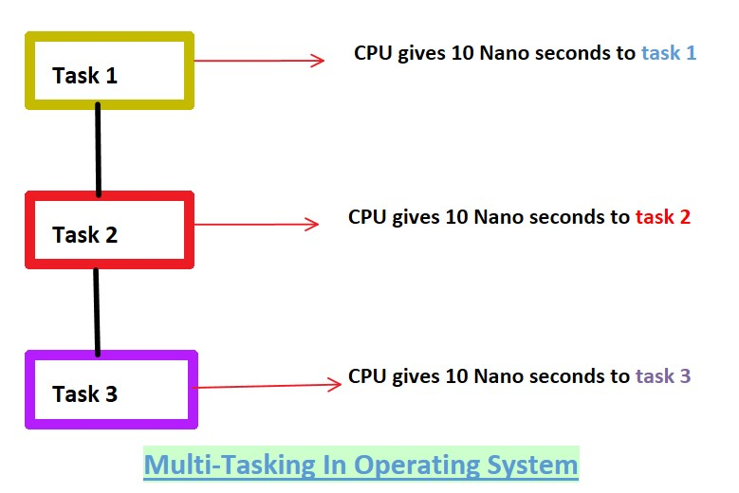

- In the diagram above, three tasks are running on the computer. CPU gives 10 nanoseconds to each task. Time is shared between task 1, task 2 and task 3. If task 1 is not completed in 10 nanoseconds then task 1 have to wait until task 2 and task 3 are given time.
- Note :that one processor (CPU) can only run one process (task) at a time. CPU gives small time to each process and switch to another process.
- Main Difference between the multiprogramming and multitasking is Multiprogramming takes maximum time to execute any process, whereas multitasking takes minimum time to execute any process.

Advantages :
1. Timesharing:
2.Handle multiple users
3. Programs can run in the background

Disadvantages:

1. Limitation of memory:
- When a computer user opens many programs at a time, the computer becomes slow. The reason behind is that many programs are loaded into main memory and CPU cannot give good time for each program and response time of completing the job becomes higher. Computers with low RAM usually face this problem. One solution to this is to increase your RAM capacity.
2.CPU heat up:
- By doing multitasking, the processor becomes busy all the time and CPU heats up.
➢

4.Distributed Operating System

- A distributed operating system (DOS) is an essential type of operating system.
- The processors(CPU) communicate with one another through various communication lines (such as high-speed buses or telephone lines).
These are referred as loosely coupled systems or distributed systems.
- It connects multiple computers via a single communication channel. Furthermore, each of these systems has its own processor and memory.
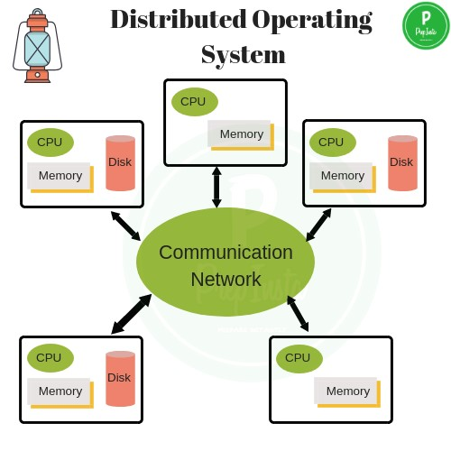

Advantages of Distributed OS:

- The distributed operating system provides sharing of resources.
- Reliability, high fault tolerance: A system crash on one server does not affect other servers.
- Scalability: In distributed computing systems you can add more machines as needed.
- Flexibility: It makes it easy to install, implement and debug new services.

Disadvantages of Distributed Systems:

- Some messages and data can be lost in the network while moving from one node(computer) to another.
- The database connected to the distributed systems is quite complicated and difficult to handle as compared to a single user system.

5. Real Time Operating System

➢ In Real-Time Systems, each job carries a certain deadline within which the job is supposed to be completed, otherwise, the huge loss will be there, or even if the result is produced, it will be completely useless. ➢ Example: washing machine, Rocket to lunching, flight control ➢ There are two types of real-time operating systems.
1) Hard real-time systems:
➢ In Hard RTOS, the deadline is handled very strictly which means that given task must start executing on specified scheduled time, and must be completed within the assigned time duration.
Example:Missile launching system, Aircraft systems, etc.
2) Soft Real Time systems:
- It accepts some delays by the Operating system. In this type of RTOS, there is a deadline assigned for a specific job, but a delay for a small amount of time is acceptable. So, deadlines are handled softly by this type of RTOS.
Example: Online Transaction system.

Advantages of Real-time operating system:
- Easy to layout, develop and execute real-time applications under the real-time operating system.
- Task Management: A real time operating system typically takes less amount of time to shift from one task to another.

Disadvantages of Real-time operating system:

- Real-time operating systems are very costly to develop.
- The algorithms are very complex and difficult for the designer to write on.
6.Personal Computer Operating System

- Personal computer operating system are made only for personal. You can say that your laptops, computer systems, tablets etc. are your personal computers and the operating system such as windows 7, windows 10, android, etc. are your personal computer operating system.

7.Parallel or tightly coupled or Multiprocessing Operating
System

- Multiprocessor operating systems are also known as parallel OS or tightly coupled OS.
- Such operating systems have more than one processor in close communication that sharing the computer bus, the clock and sometimes memory and peripheral devices.
- It executes multiple jobs at the same time and makes the processing faster.
- If one processor fails then other processor should retrieve the interrupted process state so execution of process can continue.

System components

- A system component is a process, program, utility, or another part of a computer's operating system that helps to manage different areas of the computer.
- An operating system is a large and complex system that can only be created by partitioning into small pieces. These pieces should be a well-defined portion of the system, which carefully defined inputs, outputs, and functions.
- Although Mac, Unix, Linux, Windows, and other OS do not have the same structure, most of the operating systems share similar OS system components like File, Process, Memory, I/O device management.
- The components of an operating system play a key role to make a variety of computer system parts work together.

- There are the following components of an operating system, such as:
- Process Management
- File Management
- Network Management
- Secondary Storage Management
- I/O Device Management
- Security Management

1. Process Management:

- A process is basically a program in execution.
- When a program is loaded into the memory and it becomes a process.
- The process management component is a procedure for managing the many processes that are running simultaneously on the operating system. Every software application program has one or more processes associated with them when they are running.
Example: when you use a browser like Google Chrome, there is a process running for that browser program. The OS also has many processes running, which performing various functions.
All these processes should be managed by process management, which keeps processes for running efficiently. It also uses memory allocated to them and shutting them down when needed.
The execution of a process must be sequential so, at least one instruction should be executed on behalf of the process. Functions of process management:
i. Process creation and deletion. ii. Suspension and resumption. iii. Synchronization process
iv. Communication process

2. File Management:

- A file is collection of specific information stored in the memory of computer system.

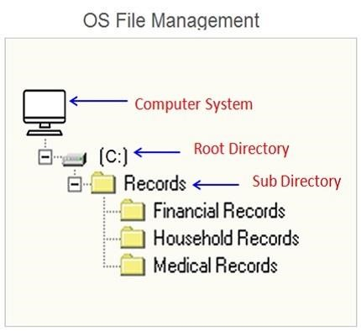

Data files can be alphabetic, numeric, or alphanumeric.
- A file management system is used for file maintenance (or management) operations.
It is is a type of software that manages data files in a computer system.
- A file management system has limited capabilities and is designed to manage individual or group files, such as special office documents and records.
Functions :
- File and directory creation and deletion.
- For manipulating files and directories. ➢ Mapping files onto secondary storage.

3.Network Management

- Network management is the process of administering and managing computer networks.
- It includes performance management, provisioning of networks, fault analysis, and maintaining the quality of service.

- 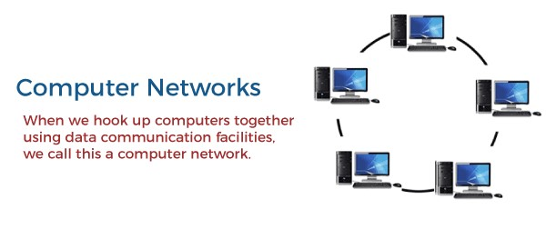
The computers in the network are connected through a communication network, which can configure in many different ways.

The network can fully or partially connect in network management, which helps users design routing and connection strategies that overcome connection and security issues.
A distributed system is a collection of computers or processors that never share their memory and clock.
Functions:
- A distributed system also offers the user access to the various resources the network shares.
- It helps to access shared resources that help computation to speed up or offers data availability and reliability.

4.Secondary Storage Management

- The most important task of a computer system is to execute programs. These programs help you to access the data from the main memory during execution. This memory of the computer is very small to store all data and programs permanently.
- The computer system offers secondary storage to back up the main memory.

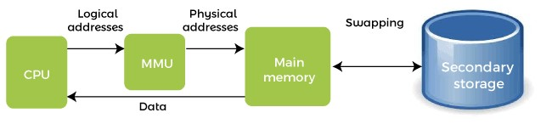

- Today modern computers use hard drives/SSD as the primary storage of both programs and data. However, the secondary storage management also works with storage devices, such as USB flash drives and CD/DVD drives.

Functions:
- Storage allocation
- Free space management
- Disk scheduling

5. I/O Device Management

- OS manages I/O devices & make the I/O process effectively.
- OS accepts the input from the input device(keyboard)stores it in main memory, and ask the CPU to process it & finally provides the result to the output devices(screens/printers)for output.
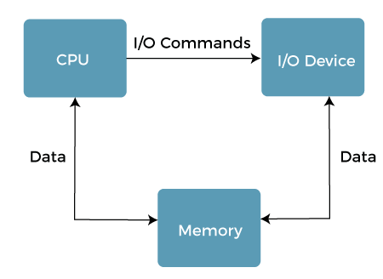

Functions:
- It offers a buffer caching system
- It provides general device driver code
- It provides drivers for particular hardware devices.
- I/O helps you to know the individualities of a specific device.

6. Security Management

- Security refers to providing a protection system to computer system resources such as CPU, memory, disk, software programs and most importantly data/information stored in the computer system.
- If a computer program is run by an unauthorized user, then he/she may cause severe damage to computer or data stored in it. So a computer system must be protected against unauthorized access, malicious access to system memory, viruses, worms etc.

Operating System services

➢ An Operating System provides services to both the users and to the programs.
- It provides programs an environment to execute.
- It provides users the services to execute the programs in a convenient manner.
➢ Following are a few common services provided by an operating system:
- User Interface
- Program Execution
- File system manipulation
- Input / Output Operations
- Communication
- Resource Allocation
- Error Detection
- Accounting
- Security and protection
1.User Interface:
➢ An Interface is required to communicate with the user. ➢ There are 3 types of user interfaces.
- Command line interface (CLI):The command line interface (CLI) usually deals with using text commands and a technique for entering those commands. Example: MS-DOS
- Graphical user interface (GUI): It is the common user Interface that includes Graphical representation like buttons and icons, and communication can be performed by interacting with these icons rather than the usual textbased or command-based communication.
- Program Execution:
  - The operating system must have the capability to load a program into memory and execute that program.
  - program must be able to end its execution, either normally or abnormally / forcefully.
- File system manipulation:
  - Programs need has to be read and then write them as files and directories.
  - File handling portion of operating system also allows users to create and delete files by specific name along with extension, search files.
- Input / Output Operations:
  - An Operating System manages the communication between user and device drivers.
  - I/O operation means read or write operation with any file or any specific I/O device.
  - Operating system provides the access to the required I/O device when required.
5.Communication:
  - Processes executing on same computer system or on different computer systems can communicate using operating system support. Communication between two processes can be done using shared memory or via message passing.
- Resource Allocation:
  - When multiple jobs running concurrently, resources must need to be allocated to each of them.
  - Resources can be CPU cycles, main memory storage, file storage and I/O devices. CPU scheduling routines are used here to establish how best the CPU can be used.
- Error Detection:
  - Errors may occur within CPU, memory hardware, I/O devices and in the user program. Following are the major activities of an operating system with respect to error handling − ➢ The OS constantly checks for possible errors.
  - The OS takes an appropriate action to ensure correct and consistent computing.
- Accounting:
  - Operating system Keeps track of time and resources used by various tasks and users, this information can be used to track resource usage for a particular user or group of users.
- Security and protection:
  - Security refers to providing a protection to computer system resources such as CPU, memory, disk, software programs and most importantly data/information stored in the computer system.
  - The protection focuses on internal threats in a computer system while security focuses on external threats to a computer system. An operating system provides a mechanism to prevent interference with logical and physical resources.

SYSTEM CALLS
- A system call is a way for programs to interact with the operating system.
- A computer program makes a system call when it makes a request to the operating system's kernel.System call provides the services of the operating system to the user programs via Application Program Interface(API).
- Program execution can made two ways.
- User mode: can’t access any hardware resources.
- Kernel mode : can access hardware resources like printer,RAM..etc.
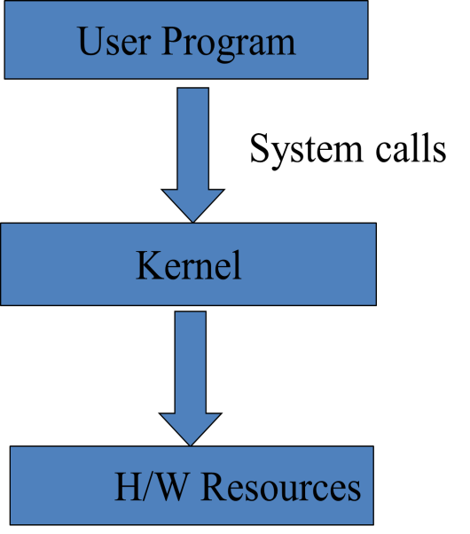
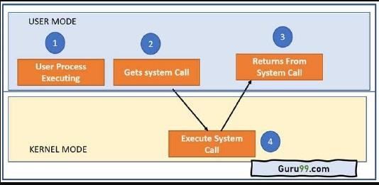

As you can see in the above-given System Call example diagram. Step 1) The processes executed in the user mode till the time a system call interrupts it.
Step 2) After that, the system call is executed in the kernel-mode on a priority basis.
Step 3) Once system call execution is over, control returns to the user mode.,
Step 4) The execution of user processes resumed in Kernel mode.

Why do you need System Calls in OS?

- Reading and writing from files demand system calls.
- If a file system wants to create or delete files, system calls are required.
- System calls are used for the creation and management of new processes.
- Network connections need system calls for sending and receiving packets.
- Access to hardware devices like scanner, printer, need a system call.

Types of System calls
There are the five types of System Calls in OS:
- Process Control
- File Management
- Device Management
- Information Maintenance
- Communications
1. Process Control
- These system calls deal with processes such as process creation, process termination etc. Functions:
Windows
CreateProcess()
ExitProcess()
WaitForSingleObject()
Unix
Fork()
Exit()
Wait()
2.File Management:
- File management system calls handle file manipulation jobs like creating a file, reading, and writing, open&close files etc. Functions: Windows
CreateFile()
ReadFile()
WriteFile()
CloseHandle()
UNIX
Open(), Read(), Write(), Close()
- Device Management:
  - Device management does the job of device manipulation like reading from device buffers, writing into device buffers, etc.

Functions:
Windows
SetConsoleMode()
ReadConsole()
WriteConsole()
UNIX
Ioctl()
Read()
Write()

- Information Maintenance:
  - These system calls handle information and its transfer between the operating system and the user program. Functions:
Windows
GetCurrentProcessID()
SetTimer()
Sleep()
UNIX
getpid() alarm() sleep()

- Communication:
  - These system calls are useful for interprocess communication. They also deal with creating and deleting a communication connection.
Function:
Windows:
CreatePipe()
CreateFileMapping()
UNIX
pipe()
shmget()

Process concepts
➢A process is a program in execution. The execution of a process progresses in a sequential fashion.
➢ A single program can create many processes when run multiple times.
Example: when we open a .exe file multiple times, multiple processes are created.
The Process:
➢When a program is reside in the hard disk and it becomes a program.
➢When a program is loaded into main memory and it becomes a ”process”.
➢The process memory is divided into four sections:
i. Text section/ program code segment:
- Text section stores instructions of a program.
- For example: a program may contain 10 instuctions ,that instructions are stored in text section.
Diagram of Process in memory
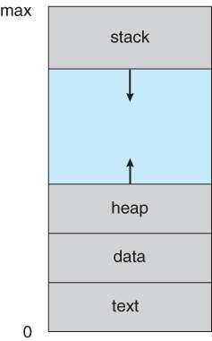
- Data Section: It mainly stores global variables and static variables.
- Heap Section: The heap is used for dynamic memory allocation to a process during its run time.

Ex: Pointers
iv. Stack section: The process Stack contains the temporary data such as method/function parameters, ,local variables.
Process States
- The state of a process refers to what the process is currently doing.
- Processes in the OS can be in any of the following states(new, ready, running, waiting. Terminated).
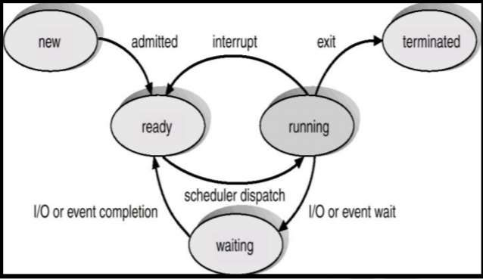
Fig. Diagram of process state
➢The minimum no.of states is five.
- New state: The new process is created when a specific program calls from secondary memory(hard disk) to primary memory(RAM).
- Ready state : In a ready state, the process should be loaded into the primary memory, which is ready for execution.
- Running state: Once the process has been assigned to a processor(CPU)by the os, the process state is said to running state and the processor executes its instructions.
- Waiting/Block State: The process cannot run at the moment, because it is waiting for some resource to become available or for some event to occur.
➢For example, the process may be waiting for keyboard input, disk access request..etc.
V. Terminated/Exit state: Once the process finished its execution by the os and it is moved to the terminated state.

Process Control Block (PCB)
➢Every process is represented in the operating system by a process control block, which is also called a task control block.
➢Every process has its own PCB.
➢PCB specify information about the process and it is used to track the process execution satus.
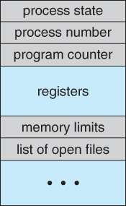

Figure - Process control block ( PCB )
- Process State: This attribute specify the current state of the process i.e., whether it is ready, running, waiting, or whatever.
- Process ID(PID): Each of the process has its own unique identification number in operating system. This PID is used to identify the processes.
- Program Counter: Program Counter is a pointer that holds the address of the next instruction to be executed for this process.
- CPU registers : CPU register is one of a small set of data holding places that are part of the computer processor. A register may hold an instruction, a storage address, or any kind of data and it includes accumulators, index and general-purpose registers.
- Memory limits: This attribute contains information about memory management.
- Accounting information: This attribute gives the information of the resources used by that process in its lifetime. For example, CPU time, connection time, etc.
- IO status information: This attribute includes a list of I/O devices allocated to the process.
➢The architecture of a PCB is completely dependent on Operating System and may contain different information in different operating systems.

Context Switch
➢The process of saving the context of one process and loading the context of another process is known as Context Switching. In simple terms, it is like loading and unloading the process from the running state to the ready state.
➢When CPU switches to another process, the system must save the state of the old process and load the saved state for the new process.
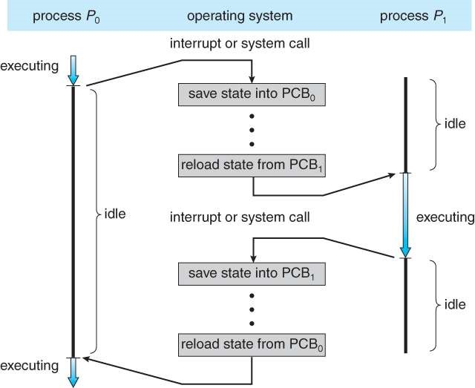
This Diagram showing CPU switch from process to process

Process Scheduling
Definition: The process scheduling is the activity of the process manager that handles the removal of the running process from the CPU and the selection of another process on the basis of a scheduling algorithms.
➢The objective of multi-programming is, it allow more than one process to be loaded into the executable memory at a time. so that CPU utilization can be increased.
➢The objective of time sharing is to switch the CPU among processes.so, frequently that users can interact with each program while it is running.
➢To meet this objectives, the process schedulers selects an available process(from set of several available processes) for program execution on the cpu.
- For a single-processor system there will never be more than one running processes.
- If there are more processes, the remaining will have to wait until the cpu is free and can be rescheduled(process scheduler is responsible for remaining processes).

Process Scheduling Queues
- The OS maintains all PCBs in Process Scheduling Queues.
- The OS maintains a separate queue for each of the process states and PCBs of all processes in the same execution state are placed in the same queue.
- When the state of a process is changed, its PCB is unlinked from its current queue and moved to its new state queue.
- The Operating System maintains the following important process scheduling queues :
  - job queue
  - Ready queue
  - Device queues
- job queue: This queue contains list of all the processes which are in the system.
Generally the content of the job queue will be stored in hard disk. so, the job queue is reside in the hard disk(secondary memory).
- Ready queue : This queue contains list of all the processes which are ready and waiting to execute. A new process is always put in this queue.
➢Ready queue is residing in main memory.
- Device queues: This queue contains list of all the processes which are waiting for IO operations. it may be any operation either I/O (reading data from the file/writing data into the file).
➢Let a process is wait for a IO operation than the corresponding process will be put in device queue.
Queue diagram representation of process scheduling
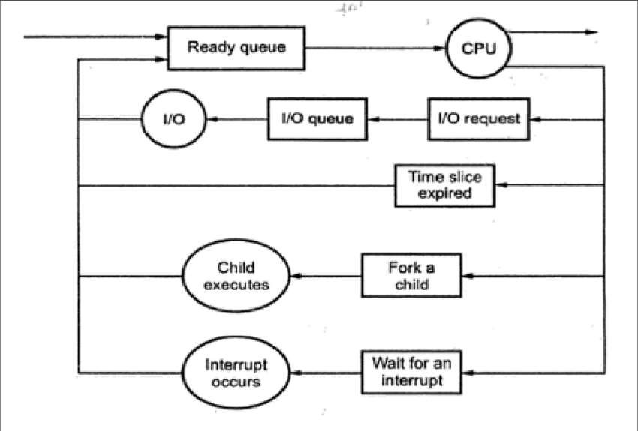
- Every new process first put in the ready queue and wait until it is selected for execution. So, the OS loads the processes from the job queue to the ready queue.
- Next OS allocates the one of the process to the cpu and it is executing.
- Some times, if the process is waiting for an IO operations that is know as IO request than that process is moved to the I/O queue.
➢ Once the IO operation is completed than the corresponding process is ready for execution. So, the process is moved to the ready queue.
- We have different types of scheduling algorithms. In that round robin is require particular time slice period for process execution.
➢If the time slice period is expired than the corresponding process is moved to ready queue.
- While cpu is executing a process. Let assume a process produces a child process with the help of fork function than the corresponding child process has to be completed its execution.so, that process is moved to ready queue. vi. While a cpu executing a process , it receives an interrupt from the OS .Once interrupt occur than the corresponding process has to be moved to the ready queue. After some time the OS allocates that process to the CPU.

Types of process schedulers
- Schedulers are special system software which handle process scheduling in various ways.
- Schedulers are of three types :
- Long-Term Scheduler(LTS)
- Short-Term Scheduler(STS)
- Medium-Term Scheduler(MTS)
1. Long-Term Scheduler:
- It is also called a job scheduler.
- A long-term scheduler determines which programs are admitted to the system for processing. It selects processes from the job queue(Secondary memory) and loads them into main memory for execution.
- Process loads into the memory for CPU scheduling.
➢Long-Term Scheduler mainly controls the degree of multiprogramming.The purpose of LTS is to choose a perfect combination of IO bound and CPU bound processes among the jobs present in the secondary memory(Job queue). so, the LTS increases efficiency.
➢If the job scheduler chooses more IO bound processes then all of the jobs may reside in the blocked state all the time and the CPU will remain idle most of the time. This will reduce the degree of Multiprogramming.
- Therefore, the Job of long term scheduler is very critical and may affect the system for a very long time.
- Short term scheduler:
➢Short term scheduler is also known as CPU scheduler. It selects one of the Jobs from the ready queue(ready queue reside in main memory) and dispatch to the CPU for the execution.
➢Short term scheduler mainly controls the degree of frequency.
➢Short-term schedulers, also known as dispatchers, make the decision of which process to execute next. Its main objective is to increase system performance.
➢Short-term schedulers are faster than long-term schedulers.
- Medium Term Scheduler:
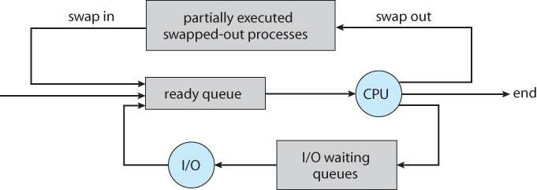
➢Medium term scheduler takes care of the swapped out processes. If the running state processes needs some IO time for the completion then there is a need to change its state from running to waiting.
➢Addition of a medium-term scheduling to the queuing diagram:

➢The primary objective of medium-term scheduler is to perform swapping.
➢It reduces the degree of multiprogramming. The swapping is necessary to have a perfect mix of processes in the ready queue.
➢Let cpu executing a process at that time OS sends an interrupt to the cpu. so, cpu stops execution of that process.that partially executed process will swapped to the hard disk that should be done by the MTS.
➢After some time that partially executed process will be moved to the ready queue(main memory) from the hard disk(Secondary memory) the process is known as swapping.
CPU Burst Cycle and I/O Burst Cycle or
CPU bound process and IO bound process
➢CPU burst is when the process is being executed in the
CPU.
➢ I/O burst is when the CPU is waiting for I/O operations for further execution. After I/O burst, the process goes into the ready queue for the next CPU burst.
➢CPU instructions are known as CPU Burst.
➢IO instructions are known as IO Burst.
➢Example: If you take any process ,than the process does’t take entire time for cpu. In addition to cpu related instructions it also contain IO instructions. So, we can say that the process is a combination of CPU instructions and IO instructions.
➢First any process start with CPU burst after that IO burst
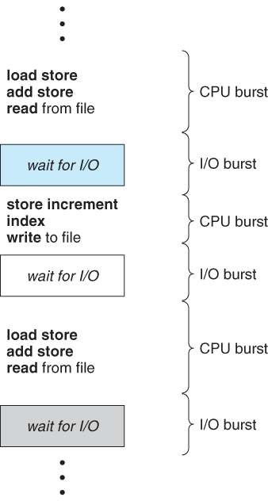
….likewise.
➢The last burst should be cpu burst. so, any process should start with cpu burst and ends with cpu burst time.

➢CPU mainly perform ALU operations (arithmetic,logical, shift operations).
We have two types of processes:
i. CPU bound process: it means that process is taking more cpu time and it is utilizing less IO time.
➢ In this we have more CPU instructions and less IO instructions. That means we are not use IO in efficient manner.
ii. IO bound process: it means that process is taking more IO time and it is utilizing less CPU time.
➢ In this we have more IO instructions and less CPU instructions. That means we are not use CPU in efficient manner.

CPU Scheduling
➢CPU Scheduling is a process of determining which process will own CPU for execution while another process is on hold.
➢The main task of CPU scheduling is ,Whenever the CPU becomes idle, the OS at least select one of the processes available in the ready queue for execution.
➢The selection process will be carried out by the CPU scheduler(STS). It selects one of the processes in memory that are ready for execution.
Types of CPU Scheduling
Two kinds of Scheduling methods:
1. Preemptive Scheduling:
- It is used when a process switches from running state to ready state (or ) waiting state to ready state.
- When the burst time of process is greater than cpu cycle/cpu time, it is placed back in to the ready queue and it will execute in next time.
- In this, the tasks are mostly assigned with their priorities. Sometimes it is important to run a task with a higher priority before another lower priority task, even if the lower priority task is still running. The lower priority task holds for some time and resumes when the higher priority task finishes its execution. So, here forcible execution is allowed. And here cpu utilization is high.
- Preemptive Scheduling Algorithms are round-robin (RR), preemptive priority, SRTF (shortest remaining time first).
2. Non-Preemptive Scheduling
➢It is used when a process terminates (or ) a process switches from running state to wating state.
➢No process is interrupted until it is completed, and after that processor(CPU) switches to another process. so, here forcible execution is not allowed. And here cpu utilization is low.
➢Non-Preemptive Scheduling Algorithms are First Come First Serve (FCFS), shortest Job first, Non-Preemptive priority scheduling algorithm.

Operations on Processes
➢The processes in most systems can execute concurrently, and they may be created and deleted dynamically.
➢The operating system must provide a mechanism for process creation and termination.
➢Mainly we can perform two operations on process.
1. Process creation 2. Process deletion
1. Process creation: During execution, A process can also create several new processes using fork ()system call. so, the creating(existing) process is called the parent process and the new processes are called the children of parent process. And child processes intern create there own child processes. thus a tree will be formed.
➢Most OS identify processes according to a unique process identifier(PID), which is an integer number.
➢It can be used as an index to access various attributes of a process with in the kernel.
➢When a process creates a child process, that child process will need certain resources(cpu time, memory) to execute its task.
➢How to share the resources among the child processes?
➢Whenever a parent process creates a child process than the parent process can shares all of its resources with its children (or)
➢Parent process can share only some of its resources with its children (or)
➢Parent process never share any resources with its children. A child process can execute its own.
- How a parent and child processes gets executed?
- When a process create a new process, two possibilities for execution exists:
- Parent and child processes may execute concurantly.
- Parent process has to wait until the child process completed its execution. So, once the child process execution is terminated than only the parent process has to admitted.
Address space of child process:
There are also two possibilities for the new process.
i. Child is duplicate of parent process means whenever a parent process creates a child process then the child process gets exact duplicate copy of the parent process.
- Every process represented with the help of PCB. All the PCB information is same for parent and child process expect PID. so, PID is different for parent and child process. ii. Child process may be replaced with a new program.
- 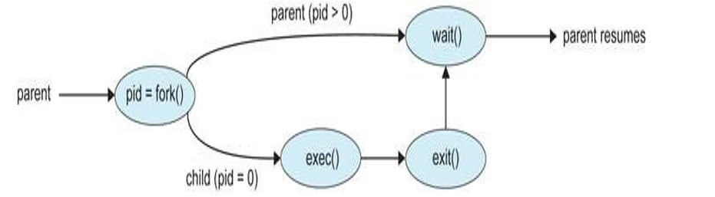
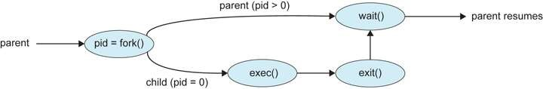
Example :UNIX Os
- In UNIX , we have fork() system call, this system call is used to create child process.
- Exec() system call , child process may have a new programs loaded into its address space.

2. Process Termination/Process deletion:
- Whenever a process executes all of its instructions then the process request to the OS for deleting the process by using the exit() system call.
- There are two methods a process can terminate:
- Normal termination : When a process is terminated successfully, the resources that were being utilized by the process are released by the operating system.
- Forced Termination: A parent process can terminate its child process by invoking the appropriate system call. The parent can terminate the child due to the following reasons:
- When a Child process exceeds its usage of resources, then that process has been terminated.
- When a Parent exits and OS does not allow child to run if parent terminates.
- If a process terminates, then all its children must also be terminated . This process referred to as cascading termination.
Cooperating Process
- In multiprogramming environment multiple processes are coexist.
- single program may be broken into a number of processes.
- The processes are classified into two categories :
  - Independent processes
  - Cooperating processes/dependent process
i. Independent processes:
- In independent process, one process is not depending on another process.
- Execution of one process does not affects the execution of other process. So, here each process is independent.
- An independent process does not share any data with any other process.
ii. Cooperating processes:
➢ In cooperating process, one process is depending on another process.
➢In cooperating process, execution of one process can affect or be affected by the execution of other process.
➢A cooperating process shares data with other processes in a system.
➢Cooperating processes can communicate in a shared memory environment.
➢Advantages of Cooperating Process
OR
The various reasons for using cooperating processes are :
1. Information Sharing:
➢ When several users want to access a same piece of information, they require concurrent access to these types of resources(file).
- Modularity: Modularity involves dividing complicated tasks into smaller subtasks. These subtasks can completed by different cooperating processes. So, the required tasks are completed more quickly and efficiently.
- Computation speedup : If we want a particular task to run faster, we must break it into subtasks, each subtask will be executing in parallel with the multiple processing elements(CPU, IO devices). so, It improves computation speed by allowing the task to be accomplished faster.
- Convenience: Even an individual user can work on many tasks at the same time like a user can be editing, listening to music, and compiling in parallel.
➢Cooperating processes need an inter-process communication (IPC) mechanism that will allow them to exchange data and information.

Inter Process Communication (IPC)
- Interprocess communication is the mechanism provided by the operating system that allows processes to communicate with each other and exchange useful information between one or more processes.
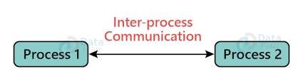
- Process executing concurrently in the os may be either independent or co-operating processes.
- In independent process, one process is not depending on another process.
- Execution of one process does not affects the execution of other process. So, here each process is independent.
- An independent process does not share any data with any other process.
- In cooperating process, execution of one process can affect or be affected by the execution of other process.
- A cooperating process shares data with other processes in a system.
➢Co-operating processes require an IPC that will allow them to exchange data and information.
➢There are two fundamental models of IPC:
- Shared memory
- Message passing.
1. Shared memory:
- Co-operating processes are can communicate with each other by using shared memory.
- Shared memory is a memory shared between two or more processes.
- Shared memory is the fastest inter-process communication mechanism.
- Shared memory region resides in the address space of the process , creating the shared memory segment.
Example:
➢If the process wants to create the communication and it has some data to share, then establish the shared memory region in its address space.
➢After that, another process wants to communicate and tries to read the shared data, and must attach itself to the initiating process’s shared address space. So, a process can exchange information by reading data from the shared region and writing data to the shared region.
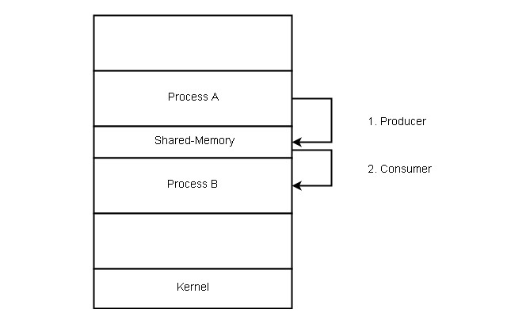
➢Shared memory does not use kernel.
Example: Producer and Consumer Problem
➢In operating System Producer is a process which is able to produce data/item.
➢Consumer is a Process that is able to consume the data/item produced by the Producer.
➢Both Producer and Consumer processes share a common memory location known as a buffer. This buffer is a space of a certain size in the memory of the system which is used for storage.
➢The producer produces the data into the buffer and the consumer consumes the data from the buffer.
➢There are two types of buffers.
1. Unbounded buffer 2. bounded buffer.
- Unbounded buffer:
➢In which the Producer can keep on producing items and there is no limit on the size of the buffer.
- Bounded buffer:
- In which the Producer can produce up to a certain number of items before it starts waiting for Consumer to consume it.
- First, the Producer and the Consumer will share some common memory, then the producer will start producing items.
➢If the total produced item is equal to the size of the buffer, the producer will wait to get it consumed by the Consumer.
➢Similarly, the consumer will first check for the availability of the item. If no item is available, the Consumer will wait for the Producer to produce it.
- If there are items available, Consumer will consume them.
2. Message passing:
➢Message Passing provides a mechanism to allow processes to communicate and to synchronize their actions without sharing the same address space.
➢It is used in distributed environments where the communicating processes are present on remote machines which are connected with the help of a network.
➢Message passing is a time consuming process because it is implemented through kernel (system calls).
➢It is useful for sharing small amounts of data so that conflicts need not occur.
➢In message passing the communication is slower when compared to shared memory technique.
➢Message passing provides two operations i.e, send() for Send message and receive() for Receive message.
➢Example: chat programs on World Wide Web.
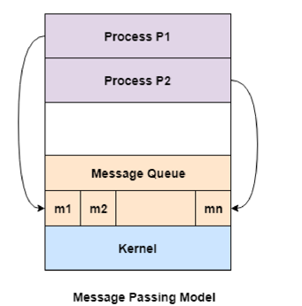
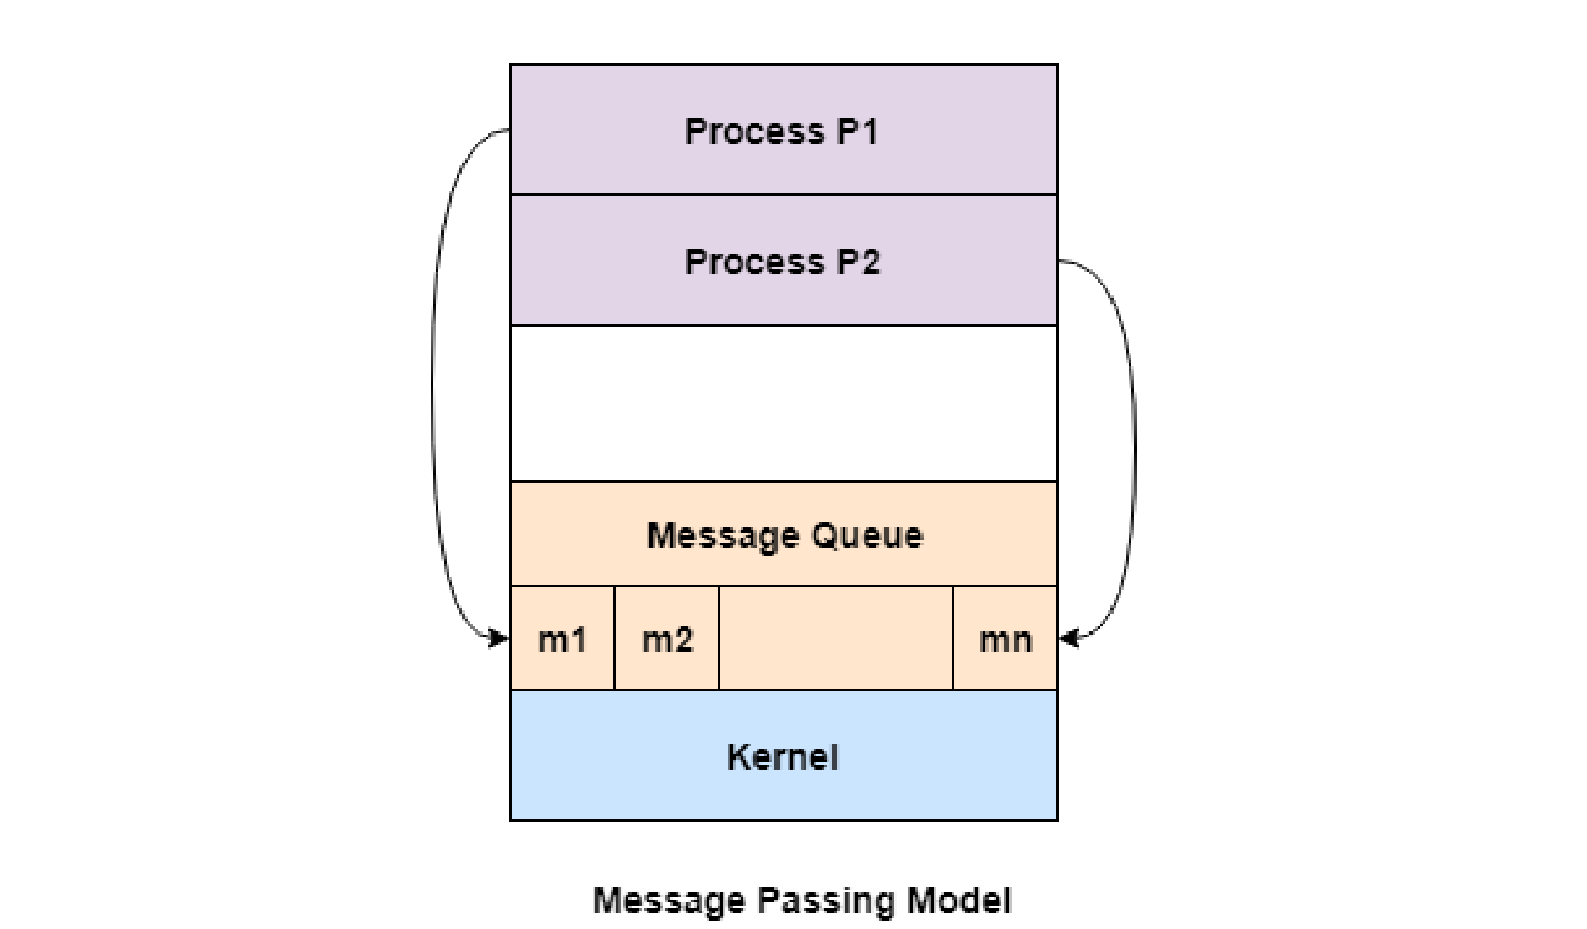
➢If process P1 and P2 want to communicate they need to send a message to and receive a message from each other that means here a communication link exists between them.
➢This link can be implemented by read() and write() operation.

➢The message size can be of fixed size or of variable size(larger messages).
➢ If it is of fixed size, it is easy for an OS designer but complicated for a programmer and
➢if it is of variable size then it is easy for a programmer but complicated for the OS designer.
➢Generally, message is sent using FIFO style.

THREADS
➢A thread is a segment of a process (or) a thread is a flow of execution with in a process in sequential manner.
➢A process can have multiple threads and these multiple threads are contained with in a process.
➢A thread has a thread id, a program counter, a register set, and a stack. It does not share to other threads.
➢It shares code, data and other os resources such as open files and signals with other threads in the process.
➢Threads have same properties(same address space, limited instructions) as of the process so, threads are called as light weight processes.
➢The traditional single-threaded program can do only one task, the multi-threaded process can do more than one tasks at a time.
- Threads achieve parallelism by dividing a process into multiple threads.
- 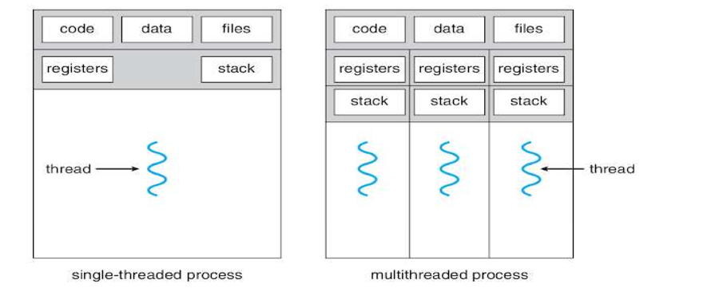
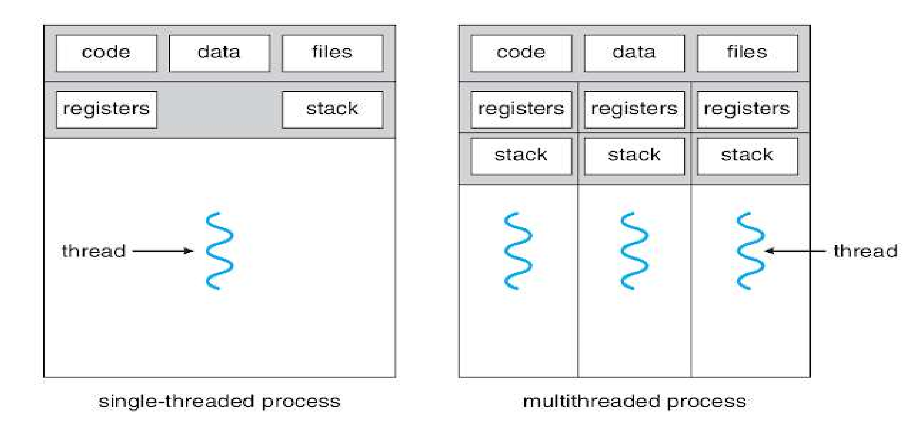
- Example1: in a browser, multiple tabs can be different threads. MS Word uses multiple threads: one thread to format the text, another thread to process inputs, etc.
- Each thread contain thread control block(TCB) and process contain process control block(PCB). So, here each and every thread has its own TCB like a process.

➢Threads are used to increase the performance of the applications.
➢Example2 :While playing a movie on a device the audio and video are controlled by different threads in the background.
➢Advantages of Threads:
- Responsiveness:
If the process is divided into multiple threads, if one thread completes its execution, then its output can be immediately returned.
- Faster context switch:
Context switch time between threads is lower compared to process context switch. Process context switching requires more overhead from the CPU.
- Effective utilization of multiprocessor system:
If we have multiple threads in a single process, then we can schedule multiple threads on multiple processor. This will make process execution faster.
- Resource sharing:
- Resources like code, data, and files can be shared among all threads within a process.
- stack and registers can’t be shared among the threads. Each thread has its own stack and registers.
5. Communication:
➢ Communication between multiple threads is easier, as the threads shares common address space. while in process we have to follow some specific communication technique for communication between two process.
6. Enhanced throughput of the system:
➢ If a process is divided into multiple threads, and each thread function is considered as one job, then the number of jobs completed per unit of time is increased, thus increasing the throughput of the system.
Types of Threads:
In the operating system there are two types of threads.
- User level thread(ULT)
- Kernel level thread(KLT).
- User level thread(ULT):
➢The OS does not recognize the user-level thread.
➢User threads can be easily implemented and it is implemented by the user.
➢If a user performs a user-level thread blocking operation, the whole process is blocked. The kernel level thread does not know nothing about the user level thread.
➢Context switch time is less than the kernel-level threads.
➢It is faster and efficient.
➢The kernel-level thread manages user-level threads as if they are single-threaded processes. Example: java threads.
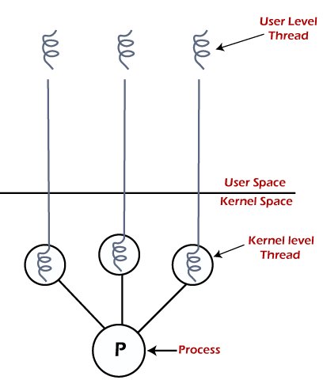
- Kernel level thread(KLT):
➢Kernel level threads are implemented and managed by the OS.The implementation of kernel threads is difficult than the user thread.
➢There is a thread control block and process control block in the system for each thread and process in the kernel-level thread.
➢Kernel level threads are implemented using system calls and Kernel level threads are recognized by the OS.
➢Kernel-level threads are slower to create and manage compared to user-level threads.
➢Context switching in a kernel-level thread is slower.
➢Even if one kernel-level thread performs a blocking operation, it does not affect other threads. Eg: Window Solaris.
S.NO | Process Thread
1. | Thread means a  Process means any program segment of a is in execution. process.
2. | The process takes more time to terminate. | The thread takes less time to terminate.
3. | It takes more time for creation. | It takes less time for creation.
4. | It also takes more time for context switching. | It takes less time for context switching.
5. | The process is less efficient in terms of communication. | Thread is more efficient in terms of communication.
Difference between Process and Thread:

S.NO Process Thread
A Thread is lightweight
The process is called
as each thread in a
- the heavyweight
process shares code, process. data, and resources.
Thread switching does
Process switching uses not require calling an
- an interface in an operating system and
operating system. causes an interrupt to the kernel.
If one process is If a user-level thread is blocked then it will not blocked, then all other 8.
affect the execution of user-level threads are other processes blocked.
The process has its own ^{Thread has Parents’}
PCB, its own Thread Process Control Block,
9. Control Block, and
Stack, and Address
Stack and common Space.
Address space.
Multi-Threading Models:
➢Draw back of single threading system(single core) is that only one task can be performed at a time.
➢Multi threading-It is a process of multiple threads executes at same time.
➢Many operating systems support kernel thread and user thread in a combined way.
➢The multi-threaded model defines the relationship between user-thread and the kernel-thread.
➢Example of such system is Solaris, windows, Mac OS.
➢Multi threading model are of three types.
- Many-to-One Model
- One-to-one
- Many-to-many
1. MANY-TO-ONE MODEL:
- In this model, we have multiple user threads mapped to one kernel thread.
- 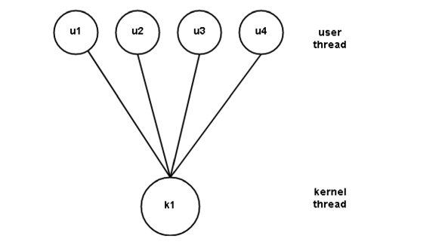
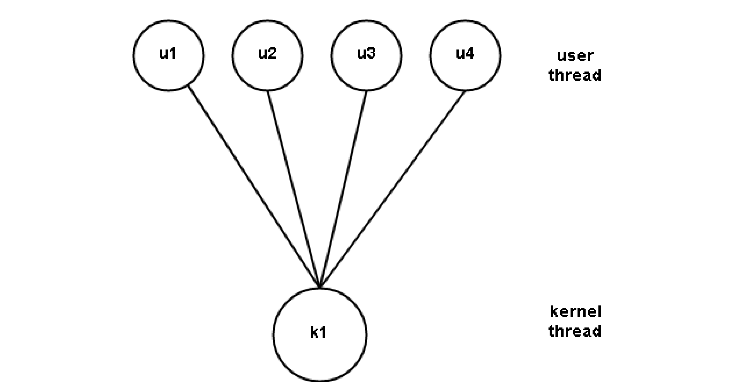
- In this model when a user thread makes a blocking system call entire process blocks.
- The thread management is done on the user level so it is more efficient.
- Only one thread can access the kernel thread at a time, hence, parallel execution of threads not possible in multiprocessors system.
2. One-to-one model:
➢This model maps each user thread to a kernel thread. It allows parallel execution of user threads on multiprocessors.
➢Problem with this model is that creating a user thread requires the corresponding kernel thread.
➢So to implement this model, the OS must restrict the number of threads. Linux, as well as Windows OS, implement this model.
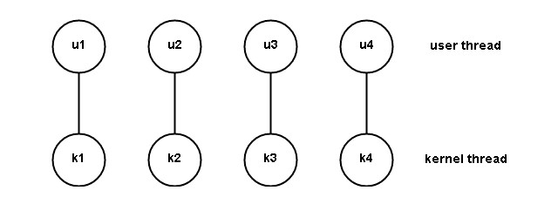
➢ As each user thread is connected to different kernel , if any user thread makes a blocking system call, the other user threads won’t be blocked.
- Many-to-many model:
- 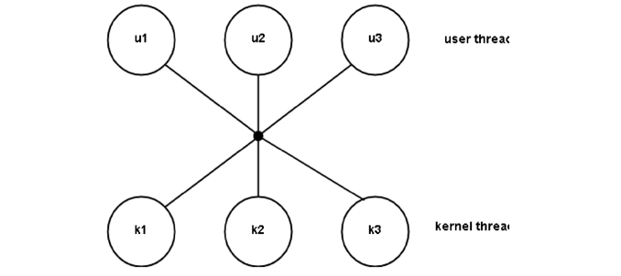
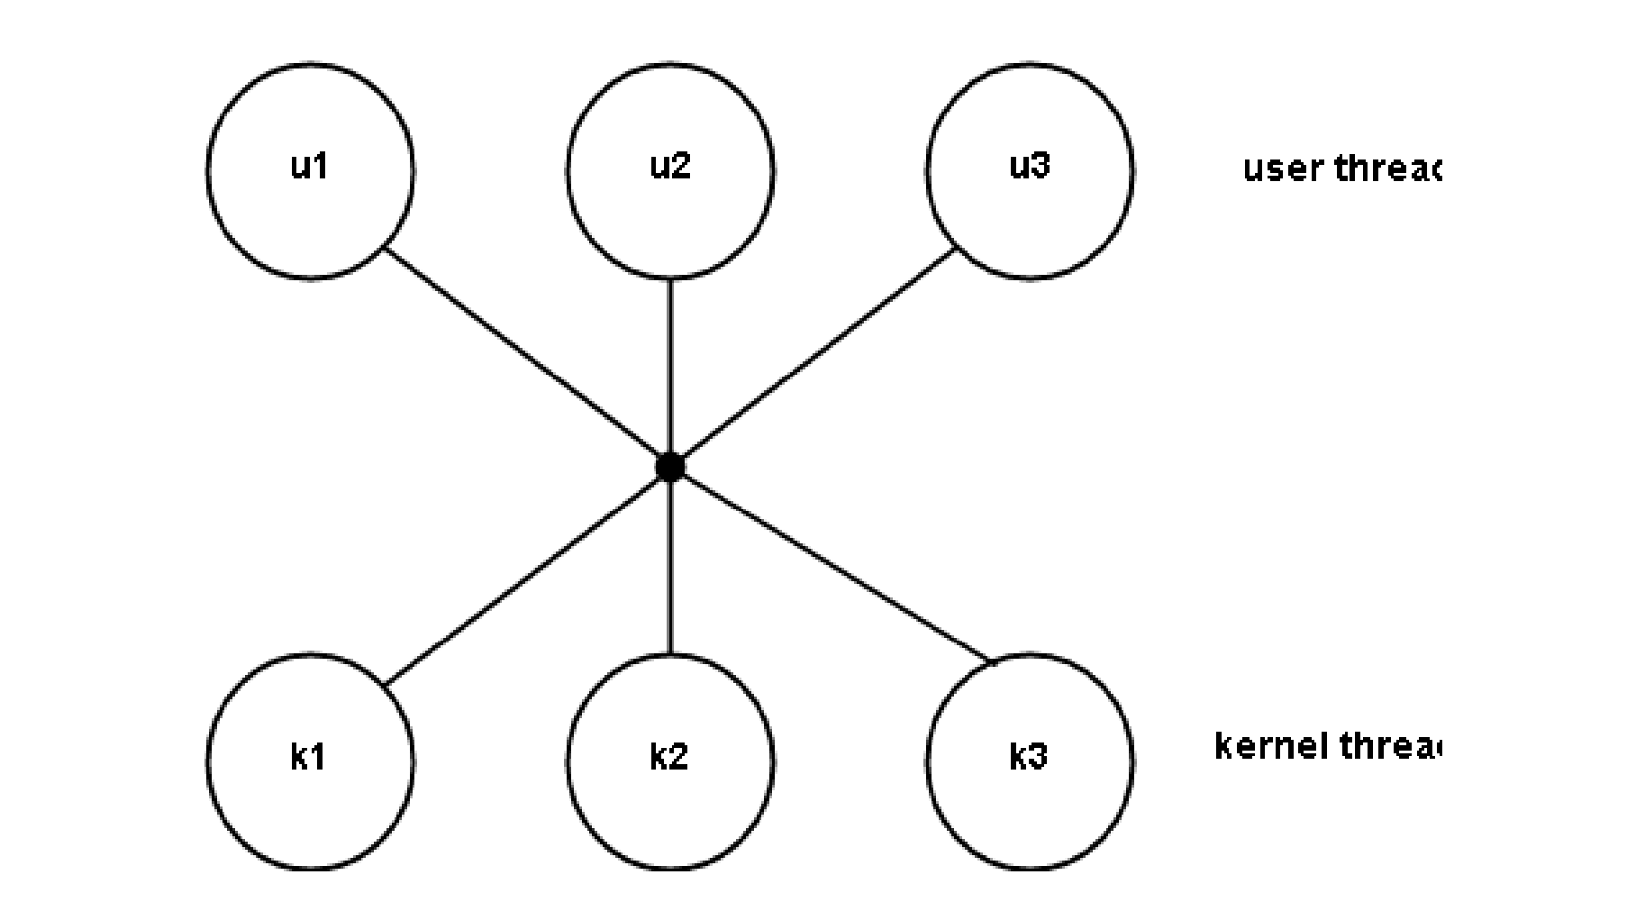
- This model, Maps many user threads to a smaller or equal number of kernel threads.
- This model is better than other models and achieves true concurrency.
- Advantage of this model is if a user thread is blocked we can schedule others user thread to other kernel thread. Thus, System doesn’t block if a particular thread is blocked.

